**PROJECT REPORT**

**ON**

**APPLICATION OF GALLIUM NITRIDE IN 5G COMMUNICATIONS**

*To be submitted by:*

**SHRUTI VERMA (BTBTL15041)**

*Under the supervision of:*

**Mr. UMAKANT GOYAL**

** DRDO-SSPL**

*For the award of the degree*

*of:*

**B.Tech**

** Electrical and Electronics Engineering**

**SCHOOL OF AUTOMATION**

**BANASTHALI VIDYAPITH**

**BANASTHALI – 304022**

**MARCH-2019**

**INDEX**

1. **INTRODUCTION**
   1. Topic of the project
   2. Objective
   3. Technology involved
   4. Gallium Nitride in 5G
   5. Why GaN in 5G technology?
   6. Usage and benefits of GaN in 5G technology
2. **FEASIBILITY STUDY**

2.1 Technically feasible?

2.2 Profits of 5G technology

**3. LITERATURE SURVEY**

3.1 Evolution of MCS(Mobile Communication System)

3.1.1 0G-Zero Generation

3.1.2 1G-First Generation

3.1.3 2G- Second Generation

3.1.4 3G- Third Generation

3.1.5 4G- Fourth Generation

3.1.6 5G- Fifth Generation

**4. REFERENCES**

1. **INTRODUCTION**

**1.1 Topic of the Project:** Application of Gallium Nitride (GaN) in 5G technology.

**1.2 Objective:**

As the different generations of cellular telecommunications have evolved, each one has brought its own improvements. The same will be true of 5G technology.

* **First generation, 1G:**   These phones were analogue and were the first mobile or cellular phones to be used. Although revolutionary in their time they offered very low levels of spectrum efficiency and security.
* **Second generation, 2G:**   These were based around digital technology and offered much better spectrum efficiency, security and new features such as text messages and low data rate communications.
* **Third generation, 3G:**   The aim of this technology was to provide high speed data. The original technology was enhanced to allow data up to 14 Mbps and more.
* **Fourth generation, 4G:**   This was an all-IP based technology capable of providing data rates up to 1 Gbps.

Any new 5th generation, 5G cellular technology needs to provide significant gains over previous systems to provide an adequate business case for mobile operators to invest in any new system.

The latest generation which is present around us is **4G technology.**Standard 4G (or 4G LTE) is around five to seven times faster than 3G, offering theoretical speeds of up to around 150Mbps. That equates to maximum potential speeds of around 80Mbps in the real world. With standard 4G you can download a 2GB HD film in 3 minutes 20 seconds on a standard 4G mobile network, while it would take over 25 minutes on a standard 3G network. The data speed rates and quality of calls has significantly used in 4G when compared with previous generations.

4G is now common throughout the world but things are about to change again by 2020. The internet of things are now real possibility and 4G will not be able to manage the huge number of connection that will be on network. It is expected that there will be more than 20 billion connected device by 2020 all of which will require connection with great capacity. This is where **5G technology** comes in force.

5G technology is widely believed to be faster, smarter and more efficient than 4G technology. With speed upto 100 Gigabytes per second, 5G is set to be as 100 times faster than 4G.

**1.3 Technology involved:**

1-Massive MIMO (multiple input and multiple output) antennas increases sector throughput and capacity density using large numbers of antennae and Multi-user MIMO (MU-MIMO). Each antenna is individually-controlled and may embed radio transceiver components. Nokia claimed a five-fold increase in the capacity increase for a 64-Tx/64-Rx antenna system. The term "massive MIMO" was coined by Nokia Bell Labs researcher Dr. Thomas L. Marzetta in 2010, and has been launched in 4G networks, such as Softbank in Japan.

2-Edge computing is a method of optimizing cloud computing systems by taking the control of computing applications, data, and services away from some central nodes (the "core area"). In a 5G network, it would promote faster speeds and low-latency data transfer on edge devices.

**1.4 Gallium Nitride in 5G technology:**

**Future 5G cellular network technology will be based on advanced Gallium nitride (GaN) technology**.Gallium nitride is a material we can use in the production of semiconductor power devices. We can also use GaN in the production of RF components and LEDs. The letters LEDs stand for light emitting diodes.The 5G cellular network will enable transmissions between machines, devices, and human beings in real time.

**1.5 Benefits of 5G technology;**

* Increased bandwidthfor all users.
* Much faster data rate speeds.
* Wider connectivity over the network.
* New technologyoptions may become available.

**1.7 Why GaN in 5G technology?**

Fifth generation (5G) networks promise to offer significantly better performance than today’s wireless networks. Specifically, these performance improvements include faster data rates, greater area traffic capacity, and lower latency. Greater network efficiency is another advantage expected with 5G. In the white paper, “ Gallium Nitride—A Critical Technology for 5G” the role that gallium-nitride (GaN) technology is likely to play in future 5G networks is been discussed.

According to the white paper, 5G promises to deliver latency below 1 ms, 20-Gb/s peak data rates, and area traffic capacity of 10 Mb/s/m2. In addition, 5G is expected to offer improved efficiency, allowing for a more “green” communications network. Furthermore, objectives of 5G include delivering increased power levels and utilizing frequencies as high as 100 GHz.

To meet green network goals, 5G networks are likely to utilize GaN technology. GaN possesses a number of characteristics that allow for an improved overall efficiency in the RF chain. Its entrance into the base-transceiver-station (BTS) market space is detailed, as GaN technology has yielded greater efficiency in this arena. Moreover, the white paper notes that manufacturers must offer several GaN variations that span a wide array of frequencies and power levels to meet a diverse range of 5G requirements.

In addition, according to the paper, GaN will overtake traditional semiconductor technologies in applications like higher-frequency, size-constrained small cells. Another prediction is that low-voltage GaN will ultimately find its way into mobile handsets. GaN can also operate in high-temperature environments, making it well-suited for passively cooled, all-outdoor base-station electronics, as well as automobile applications.

**1.6 Usage and Benefits of GaN in 5G technology:**

* It offers ultra wide band linearization, small package and high power. Hence it is suitable for MIMO/BF features employed in 5G wireless applications.
* Due to low voltage operation, small size and high linearity it can be used in small cells/DAS architecture based 5G network deployment.
* Due to high temperature and high reliability, it can be used in wide variety of devices such as cars, cameras etc.
* Due to its high frequency and high efficiency, it is used for 5G microwave applications.   
  Millimetre wave bands need high directional beamforming technology. This is achieved using large number of active antenna elements.
* GaN is ideal for this application due to its small package size and powerful performance.

1. **FEASIBILITY STUDY**

**2.1 Technically Feasible?**

To make 5G a reality, millions of “stations” will be set up (which are essentially antennas sending out the 5G signal) all across the country, in places ranging from neighbourhoods to highway. These stations are built upon fiber optic cable, which can carry the massive volumes of information that is wanted for hundreds of miles with pretty much no degradation. Because of how easily the signals can be interrupted, we may even end up bringing stations into our houses at some point as well. Essentially, the underground, wired fiber brings all the data to the 5G stations that will be everywhere, and from these stations, the “5G part” happens when the signal is wirelessly transmitted to our device.

To clarify, the reason 5G is so fast isn’t just because it’s right next to the stations. The waves themselves can carry far more information than 4G could, and the actual process of transmitting the information doesn’t have nearly as high of a latency. The technology is more powerful, but it also happens to have constraints. It’s certainly not useless. However, it’s definitely not something we’re going to see in mass market applications for a while.

In order to actually make 5G accessible to the average consumer, firstly it is needed fiber laid across pretty much the entire country. Right now, it exists primarily just in large cities (and even then, there’s no station present for 5G). Stations can just be added to existing infrastructure like lamp posts, but this effort is still an undertaking will cost up to $150 billion and take around five years, as per a Deloitte estimate. The current situation also means that 5G technologies will first come to urban areas, then suburban, and likely much later, rural as well.

While companies, such as AT&T, have already begun preparing 5G networks for deployment, it’s important to remember this isn’t true 5G. As explained by 3GPP, the organization which writes the standards, “5G will remain a marketing & industry term that companies will use as they see fit until the standards are published.

By this we conclude that though it is difficult to cover but yes **5G technology is technically feasible.**

* 1. **Profits of 5G Technology:**
* **Remote surger** -Beyond speed, the biggest benefit of 5G is its low latency, or the short lag time between a device pinging the network and getting a response. While not necessarily noticeable, there is a lag with 4G LTE. A 5G network virtually eliminates it, meaning a surgeon may not need to be in the same room as a patient in the future.
* **A touchy-feely internet-**The surgery feedback is just one example of how touch will play into the 5G network. With haptic feedback, you'll be able to transmit the tactile sensation of experience, enhancing the sights and sounds of a video experience.
* **Self-driving cars-**While companies like Google and Uber are investing in self-driving cars now, many in the industry don't believe a fully autonomous vehicle is possible without a 5G network.
* **Drones-** Similarly, 5G will unlock the true capability of drones. Lynn Comp, director of market development at Intel, cited the example of a drone flying over an oil drill with a video camera. The network will allow for precise control of the drone, while sending back high-definition video.
* **Virtual reality-**VR was a huge trend at last year's Mobile World Congress. But the technology took a back seat this year with little new hardware other than SamsungUpdate.
* **Home broadband-** The most obvious application of 5G is as a replacement for traditional home internet service. And it's coming really soon, with Verizon and AT&T already investing in trials in the US.Of course, phones will eventually get the 5G treatment. Roger Gurnani, chief information and technology architect for Verizon, teased coming back to Barcelona next year with a 5G phone.That may prove overly ambitious, but Gurnani and the rest of the industry know there's a lot of work ahead and high customer expectations to fill. In the end, that's their priority.

1. **LITERATURE SURVEY**

Creation, revolution and evolution of mobile communication system (MCS) was started in the early 1980s. During the last few decades, MCS has experienced 4 to 5 generations starting from first generation (1G) to upcoming fourth generation (4G) [1].In terms of technology, a phenomenal growth in the MCS has been witnessed by the subscribers. The importance of efficient network and efficient design has been realized by the researchers as there has been a clear shift in the technology and in the mobile technology subscriptions [2]. The first generation (1G) technology was the first developed system which relied on distributed transceivers for communication. This technology has made the large scale services possible and was implemented based on analog technology to solve the fundamental problems. In the second generation (2G), the digital system which has replaced the former technology has significantly improved the quality of wireless communication. This technology was the first to be used in the mobile system. The 3G (Third generation) has mainly focused on multimedia services and internet data rates which became as a set of standards for mobile services. These technologies were used in wide area of applications including wireless voice telephony, mobile Internet access, fixed wireless Internet access, video calls, mobile TV and etc. [A Survey: On Generation of Wireless Telephony Technology] [3] [4]. These generations has fail to provide to be included which gave rise to demand for a new system called 4G which promised to meet the above disadvantages at higher capacity and higher rate data services for mobile devices. The approaching 4G (fourth generation) MCS will solve the existing problems in earlier MCS and will provide a wide variety of new services, from high-quality voice to high-definition video to high-data-rate wireless channels. This generation is used broadly to include several types of broadband wireless access communication systems. This system will be developed to provide a comprehensive IP solution where multimedia communication can be approachable to users on an anytime, anywhere basis at higher rate when compared to previous generations. In general, MAGIC - Mobile multimedia, anytime anywhere, Global mobility Global mobility support, integrated wireless solution, and customized personal service is the term used to describe 4G system [3] .

**3.1 Evolution of MCS (Mobile Communication System)**

The number of mobile user is increasing day by day due to the growth in mobile technology and increase in its popularity. The mobile communication systems has faced many generation starting from 0G to present 4G technology and to the technologies like 5G and 7G in future. The new generations which appears in every ten years starting from 0G in 1970's is due to factors like data rate and frequency which leads to development of these generations [5]. The evolution of different generations starting from 0G to future 5G is shown in Fig.1

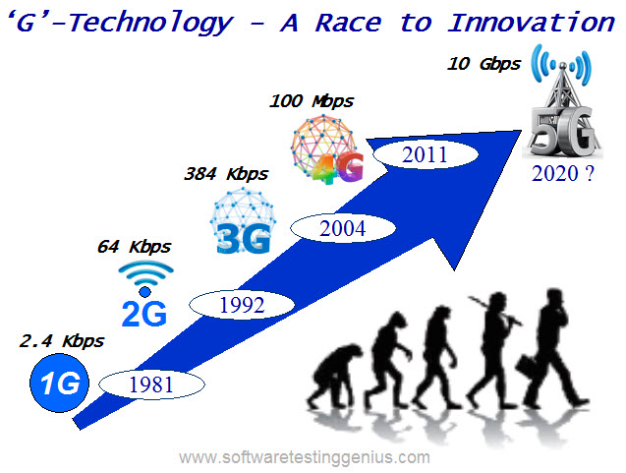

**Figure 1. Evolution of Different Generations**

**3.1.1** **0G - Zero Generation:** Before the second world war, availability of channels were very few and a mobile operator was used to set up the calls. The work phase after second world war i.e., from 1946 which is used to design a portable telephone system is categorized as zero generation (0G) as they were the predecessors of the first generation of cellular telephones. Motorola and Bell systems were the first to operate mobile telephone system (MTS) or mobile radio telephone system. Some of the technologies which were used in this generation are listed in [6][7][8]. 0.5G is the next generation technologies with some improved feature than the basic 0G technologies. The telephone systems used in this generation were quite different and they were mounted on vehicles like cars, trucks etc. Typically, the transmitter-receiver (transceiver) were mounted in the vehicle trunk and attached to the "head" (dial, display, and handset) which is mounted near the driver seat. Loggers, construction foremen, realtors, and celebrities were the primary users for basic voice communication [6][7][8].

**3.1.2 1G - First Generation:** In 1974 , the mobile communication system has started a new generation called as first generation or 1G which got completed in 1984. In earlier stages, it was primarily developed to communicate with the mobile phones through the network of distributed transceivers [9]. Normally, this generation is referred as the generation of wireless telecommunication technology which popularly known as Cell phones [7]. 1G mobile wireless communication systems is an analog frequency modulation system and the technologies which forms the base for this generation are NMT (Nordisk Mobile Telephony), AMPS(Advance Mobile Phone Service ) and CDPD(Cellular Digital Packet Data) [6]. The other standards which has been used in different countries around the world for this technology is listed in [7][ 8][10]. Some of the most important features of 1G generation system is given in Table. 1. The basic look alike structure of the mobile phones in 1G generation is shown in Fig.3 [6][9].

|  |  |
| --- | --- |
| Frequency | 824-894 MHz |
| Data capacity | Upto 2.4Kbps |
| Technology | Analog wireless |
| Standard | AMPS, CMD |
| Multiplexing | FDMA |
| Service | Only voice call |

**Table 1: Features of 1G System**

The limitations that exist in the 1G generation which led to its downfall are listed here: (a) Low capacity unreliable handoff, poor voice links. (b) No security of data as it does not allow advance encryption methods as a result a user's identification number will be used by another user for making calls (c) Unavailability of global roaming services (d) Existence of single channel to carry the data from source (a caller) to the destination (another caller) and as a result two callers cannot able to hear each other simultaneously and (e) Conversion of voice signal into digital signal does not happen [9] [3] [10]. These disadvantages has motivated the scientists and researchers to develop new communication generations system 2G which is explained in the next section.

**3.1.3** **2G - Second Generation:** After 1G, the next stage in the development of mobile communication system is 2G which was started at early 1980’s. 2G uses digital signals when compared to 1G which uses analog signals this technology were launched on Global system for mobile communication (GSM) standard in Finland by Radiolinja in 1991 [12]. The main purpose of invention of 2G to the world is for voice transmission with digital signals with up to 64 kbps as speed and the demand to manage large number of calls without any disturbances like interferences and dropped calls in the densely populated countries. This generation was step ahead when compared to 1G in providing services such as short message services (SMS), picture message services and Multi Media Message services (MMS) [9] [3]. Greater penetration intensity of the communication system is possible in this generation. This generation is more efficient when compared to previous two generations as it provides security for the users (both sender and receivers) [7]. Digital access technologies used in 2G generations system are time division multiple access (TDMA) and code division multiple access (CDMA) along with frequency division duplexing (FDD) and FDMA techniques. The efficiency of this generation is three times the efficiency of previous generation and it is due to increase in spectrum capacity[6][ 13]. The standards of 2G generations systems are GSM, IS (Interim Standard) - 95 CDMA one, pacific digital cellular (PDC), iDEN and IS-136 North American digital cellular (NADC). The explanation of each standard and the countries which adopt these standards are listed in [6] [7][ 13]. Among all the technologies in 2G generation, GSM which originates from Europe is the most admired standard as it helps in establishing international roaming and due to which this technology has used in 212 different countries across the world. In addition, this technology was beneficial to both the network operators and the users at the same particular time [7]. The GSM architecture is shown in Fig. 2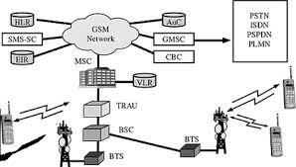

**Figure 2:** 2G GSM Architecture

The mobile phones which use 2G generation system is shown in Fig.5. Though the generation proves beneficial to the end users and mobile operators, it has its own drawbacks like (a) production of weaker digital signal with higher frequencies unable to reach the cell tower, (b) lower ability to hold complex data like videos and (c) requirement of strong digital signals to the equipment work [9][12]. Some more advanced system based on GSM technology were developed to overcome the difficulties in 2G generation system.

**2. 5 G - GPRS (General Packet Radio Service):**

The technology which is developed between the generation system , 2G (predecessor) and the generation system 3G (successor) is 2.5 G and it was introduced in 1990's. This generation uses GPRS stand where the technique of delivering the packed switched data to already existing GSM is introduced. In addition, graphics data can be send as packets with increasing Internet and Internet protocol. The other features which are available in this generation are Camera Phones, Web Browsing, EMail Messages, MMS, 64-144 kbps speed, calls, less time will be required in downloading a MP3 song. The technologies used in 2.5 G generation system are GPRS, enhanced data rates for GSM evolution (EDGE) and CDMA 2000[6][ 9].

**2.75 G - Edge Enhanced version of 2G and 2.5 G:** The generation which provides clear and fast transmission of packet and circuit switched data without glitches. In general, due its flexibility EDGE technology is preferred over GSM . The EDGE technology is augmented to black berry, N97 and N95 mobile phone users. The comparison of features of second generation systems is given in Table 2 [6][ 8].

|  |  |  |  |
| --- | --- | --- | --- |
| **Generations** | **2G** | **2.5G** | **2.75G** |
| Starts from | 1990 | 2000 | 2003 |
| Frequency | 850-1900MHz(GSM) 825- 849MHz(CDMA) | 850- 1900MHZ | 850- 1900M HZ |
| Data Capacity | 10 Kbps | 200 Kbps | 473 Kbps |
| Standard | CDMA,  TDM A,  GSM | Supported TDMA  GSM | GSM  CDMA |
| Multiplexing | GSM  CDMA | GSM  CDMA | GSM  CDMA |
| Switching | Circuit Packet | Packet | Packet |
| Service | Voice Data | MMS ,Internet |  |
| Main network | PSTN | GSM,TDMA | WCDM A |
| Handoff | Horizontal |  |  |

**Table 2: Features of 2G System**

**3.1.4** **3G - Third Generation:** 3G which was introduced in 2000 is used to denote the third generation of mobile communication and technology is a CDMA based generation and it supersede 2G, and precede 4G. This generation system eradicates problems faced in previous generations in particular the low speed and incompatible technologies like TDMA and CDMA [6][ 9][ 7]. The standards used in 3G generation system is based on International Telecommunication Union (ITU) which redefined the definition of mobile technology and supports a data transfer rate up to 2 Mbps, multimedia applications like motion video, services like GPS, IPTV, wider bandwidth. These features are possible in this generation as it works in the range of 2100 Hz, and bandwidth of 15 - 20 MHz. [8]. In addition to the features listed above, it provides flexibility for routing (repeaters, satellites, LANs and so on ) and IPTV (TV through the Internet) support[3]. The basic functionality of ITU is given in [10]. The mobile system architecture with 3G technology is shown in Fig. 3.

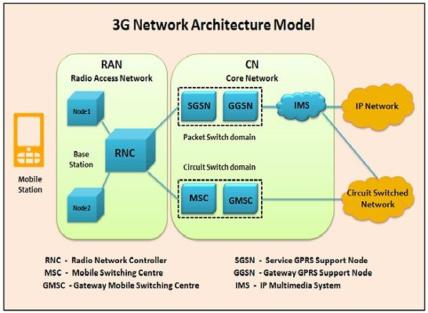

**Figure 3**: 3G Architecture

**3.1.4 4G-Fourth Generation:** The term Fourth-Generation or 4G which is a new version for third and second generation can be used to describe the next complete evolution in wireless communications. It is a conceptual framework which transmit multimedia data with high speed in wireless network. It supports about 100 Mbps and 1Gbps in full-mobility and low mobility area coverage. Commercially, this generation mobile phones provides a data transfer rates of 100Mbit/s to 1Gbit/s and spectral bandwidth up to 40MHz which were not available in wired networks. The best features of previous generation technology are included in this generation with some additive features. Therefore, the User Equipment (UE) 4G can be defined as “IP + WPAN + WLAN + WMAN + WWAN + any other stragglers = 4G”. This generation promises seamless roaming/handover and best connected service by combining multiple radio access interfaces into this network. With this feature, users will have access to more reliable wireless access even when there is a failure or loss of any of the networks [3]. The technologies which this generation comprises are: Long Term Evolution (LTE) Standard based on the GSM/EDGE and UMTS/HSPA, 3rd Generation Partnership Project (3GPP), Multiple In Multiple Output (MIMO) smart antenna technology, Orthogonal Frequency Digital Multiplexing (OFDM), 802.16e - Worldwide Interoperability for Microwave Access (WiMAX), 802.20 - Mobile Broadband Wireless Access (MBWA). The features of this generation are high performance, interoperability & easy roaming, fully converged services, low cost, user friendly interfaces, enhanced GPS services, scalability and crisis management skills.

|  |  |
| --- | --- |
| **Features** | **4G** |
| Year of start | 2010 |
| Frequency | 2 - 8 GHz |
| Data Capacity | 200 Mbps - 1 Gbps |
| Technology | LTE, Wi-Max |
| Standard | IP , LAN /WAN /PAN |
| Switching | Packet switching |
| Main network | Internet |
| Hand off | Horizontal & Vertical |

**Table 3:** Features of 4G

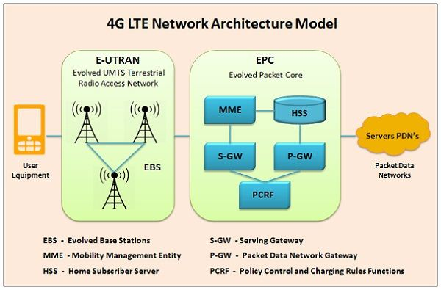

**Figure 4:** Architecture of 4G technology

**3.1.6 5G -Fifth Generation:** 5G network is very fast and reliable. The concept of hand held devices is going to be revolutionized with the advent of 5G. Now all the services and applications are going to be accessed by single IP as telephony, gaming and many other multimedia applications. As it is not a new thing in market and there are millions of users all over the world who have experienced the wireless services wireless technology. It is not easy for them to shrink from using this new 5G network technology. There is only need to make it accessible so that a common man can easily afford the profitable packs offered by the companies so that 5G network could hold the authentic place. There is need to win the customer trust to build fair long term relation to make a reliable position in the telecommunication field. To complete with the preceding wireless technologies in the market 5G network has to tender something reliable something more pioneering. All the features like telephony, camera, mp3 player, are coming in new mobile phone models. 4G is providing all these utility in mobile phone. By seeing the features of 4G one can gets a rough idea about what 5G Networks could offer. There is messenger, photo gallery, and multimedia applications that are also going to be the part of 5G. There would be no difference between a PC and a mobile phone rather both would act vice versa.

**TR MODULE AND RF FRONT END:**

***TR- Module***

The performance of modern radar systems with active phased array antennas is mainly driven by the performance of the microwave T/R modules. The concept of active aperture array is critically dependent on the availability of compact and minimum weight, low consumption and high reliability T/R modules. The large number of individual T/R modules integrated with the respective radiating elements of the active array ensures a great degree of redundancy in case of failure of elements (graceful degradation). Due to the close connection of the T /R modules to the radiating elements, the losses in both cases, transmit and receive, are low, compared to passive array systems. This leads to a low receive noise figure and high transmit efficiency.

The major functions of a T /R module are:

1. generation of transmit power,
2. low noise amplification of received signals coupled to and received from the respective radiating element,
3. phase shift in transmit and receive modes for beam steering, and
4. variable gain setting for aperture weighing during reception.

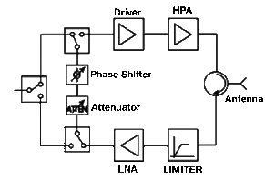

**Figure 5:** TR Module Block diagram

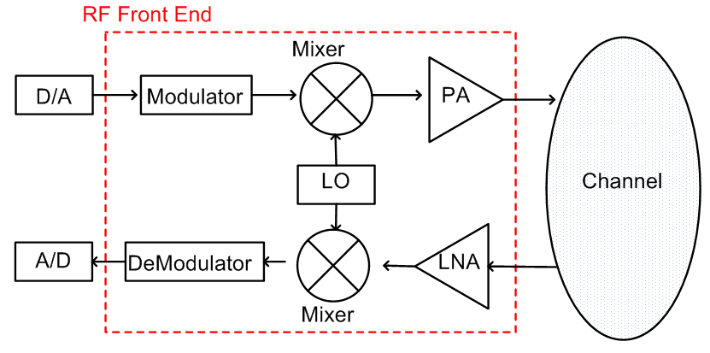

**Figure 6:** RF Front End Block Diagram

1. **REFERENCES**

**[1]** Vimalanathan P , R SriVidya, A Survey: On Generation of Wireless Telephony Technology, ,Int.J.Computer Technology & Applications,Vol 3 (4), 1467-1470.

**[2]** Amit Kumar,Dr. Yunfei Liu, Dr. Jyotsna Sengupta,Divya, Evolution of Mobile Wireless Communication Networks: 1G to 4G, Internat I onal Journal of electron I cs & communication technology,IJECT Vol. 1, IssuE 1, December 2010 ISSN : 2230-7109

**[3]** Basudeo Singh,Dr.Jasmine, A Comparative Study of Mobile Wireless Communication Networks and Technologies, International Journal of Computer Networks and Wireless Communications (IJCNWC), ISSN: 2250-3501 Vol.2, No5, October 2012.

**[4]** C. S. Patil, R.R.Karhe, M. A. Aher, Development of Mobile Technology: A Survey, International Journal of Advanced Research in Electrical, Electronics and Instrumentation Engineering Vol. 1, Issue 5, November 2012.

**[5]** Hemant Rajveer Singh, Parvinder Kaur, Neha Lekhi,Ruveena Singh, Comparative Study of Different Mobile Generation Technologies and Various Challenges in Integrating 4G and 5G, International Journal of electronics & communication technology, Vol. 6, Issue 3, July - Sept 2015

**[6]** Sarmistha Mondal, Anindita Sinha, Jayati Routh, A Survey on Evolution of Wireless Generations 0G to 5G, International Journal of Advance Research in Science and Engineering.

**[7]** Gagan Preet Kaur , Joni Birla, Jitender Ahlawat, Generations of Wireless Technology, International Journal of Computer Science and Management Studies, Vol. 11, Issue 02, Aug 2011.

**[8]** Amritpal Singh, A Review of Different Generations of Mobile Technology, International Journal of Advanced Research in Computer Engineering & Technology (IJARCET) Volume 4 Issue 8, August 2015.

**[9]** S.Venkata Krishna Kumar,Poornima.T.V, A Study of Wireless Mobile Technology, International Journal of Advanced Research in Computer Science and Software Engineering, Volume 4, Issue 1, January 2014 .

**[10]** Anmol Khanna, Arham Bengani, Atul Bhatt and ,Avdesh Bhardawaj, A Critical Review of Various Generations of Mobile Network Technologies, International Journal of Information & Computation Technology,Volume 4, Number 11.

**[11]** Sangameshkumar.Bandi, A seminar report on “4G Wireless System “DHARWAD,2010.

**[12]** Payal, Bhawna Dhruv, Praveen Kumar, A Research based study on Evolution of Cellular Generations (5G), International Journal of Advanced Research in Computer and Communication Engineering Vol. 3, Issue 7, July 2014.